39.16: The condition for a maximum is 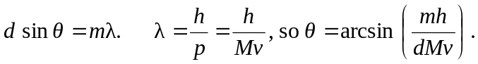 (Careful! Here, m is the order of the maximum, whereas M is the incoming particle mass.)
a) 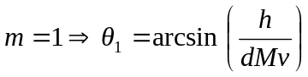
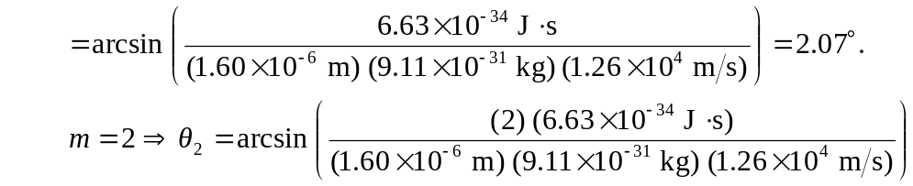
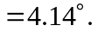
b) For small angles (in radians!) 